To submit a refund in TouchNet Marketplace for a uStore payment, system access must be assigned to you as “Fulfillers With Cancel/Refund Rights”. If this access has been established, you may proceed. If this access has not been established but should be, your supervisor must request this access to be granted. This can be completed by going to the KU E-commerce Website and completing the TouchNet User Access or User Deactivation Request Form.

1. Login to TouchNet|U.Commerce Central at <https://secure.touchnet.net:443/central>.
2. From the menu bar, select Applications -> Marketplace.

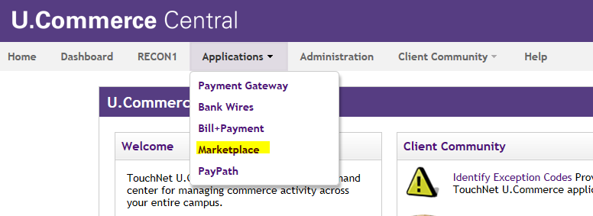

1. To proceed with the refund process, identify the Merchant Account through which the original payment transaction was processed. In this example, KU Acct Rec is the merchant account. Once identified, navigate from the Marketplace Operations Center Home to the Merchant Account (KU Acct Rec) -> Stores -> uStore (KU Accounts Receivable) -> Fulfill Orders.

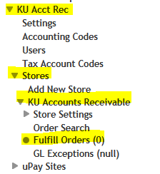

1. From the Merchant Account Fullfillments page, enter the Order Number of the payment you are wanting to refund then click “Search by Order Number”.

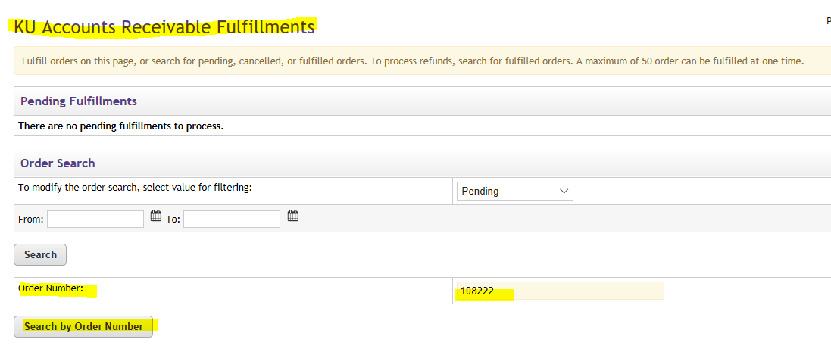

1. Now you can see the details of Order Number 108222. Click “View” in the Action box.

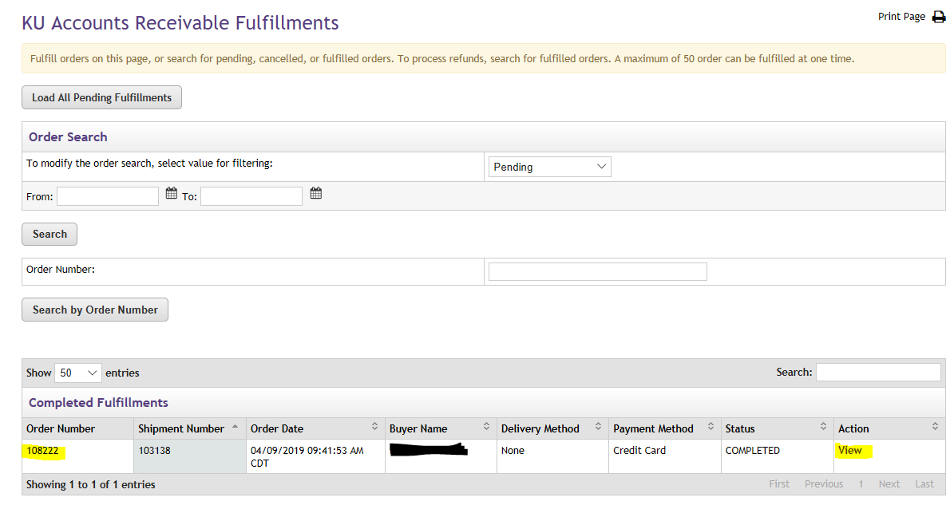

1. On the next page, there are three boxes of information: 1) Fulfillment Information 2) Fulfillment Activity and 3) Process Refund.
2. In the Process Refund box, select the quantity that is being returned then click on “Process Refund”.

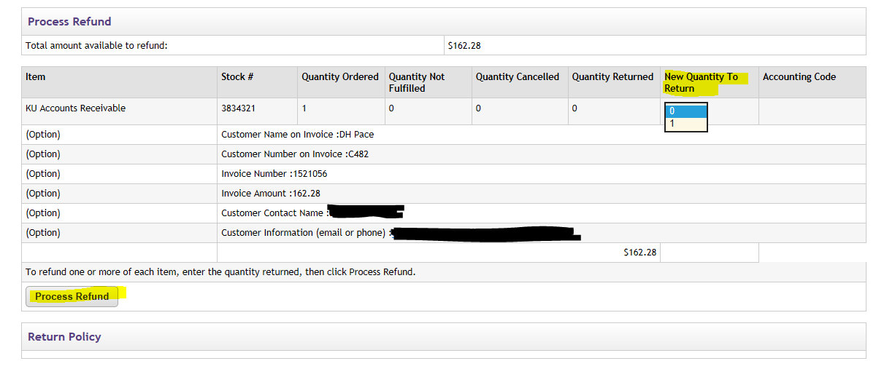

1. You do not need to complete a Miscellaneous Deposit Form (MDF) for the refunds. All activity will be recorded to department’s default funding.
2. Additional questions can be sent to [ecommerce_dl@ku.edu](mailto:ecommerce_dl@ku.edu).