To submit a refund in TouchNet Marketplace for an uPay Site payment, system access must be assigned to you as “Payment Clerk”. If this access has been established, you may proceed. If this access has not been established but should be, your supervisor must request this access to be granted. This can be completed by going to the KU E-commerce Website and completing the TouchNet User Access or User Deactivation Request Form.

1. Login to TouchNet|U.Commerce Central at <https://secure.touchnet.net:443/central>.
2. From the menu bar, select Applications -> Marketplace.

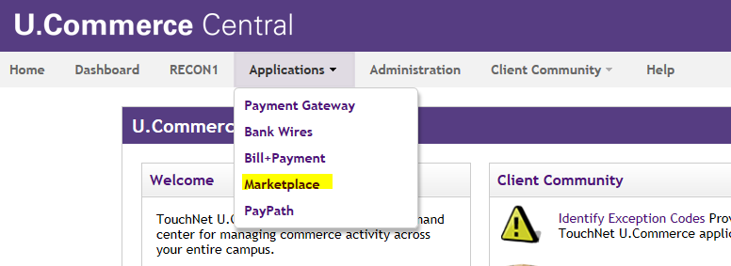

1. To proceed with the refund process, identify the Merchant Account through which the original payment transaction was processed. In this example, KU Engineering is the merchant account. Once identified, navigate from the Marketplace Operations Center Home to the Merchant Account (KU Engineering) -> uPay Sites -> uPay Site (High School Camp – 2019 Registration) -> Payment Search.

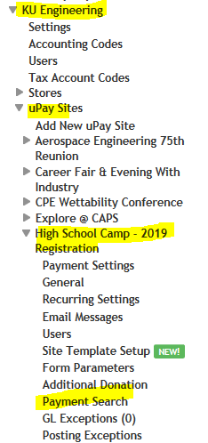

1. From the Merchant Account Payment Search page, enter the System Tracking ID of the payment you are wanting to refund then click “Run Search.

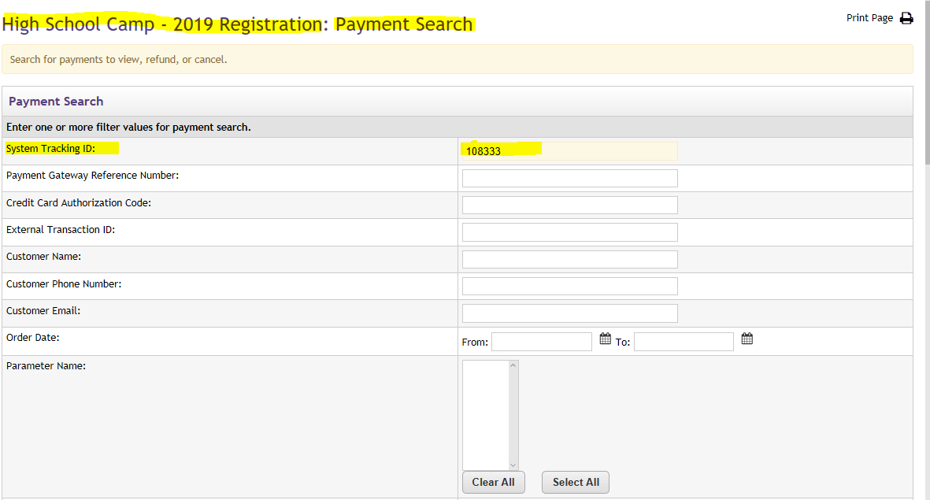

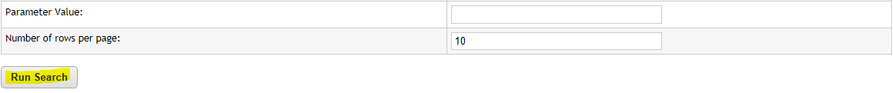

1. Now you can see the details of System Tracking ID 108333. Click on the System Tracking ID number.

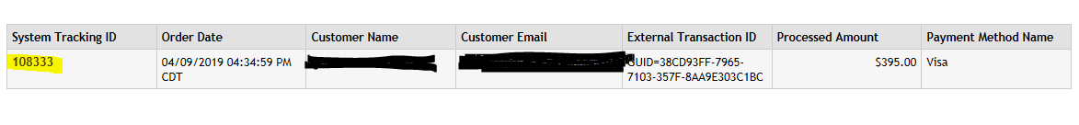

1. On the Payment Details page, there are three boxes of information: 1) Order Details 2) Return Policy and 3) Completed Payments.

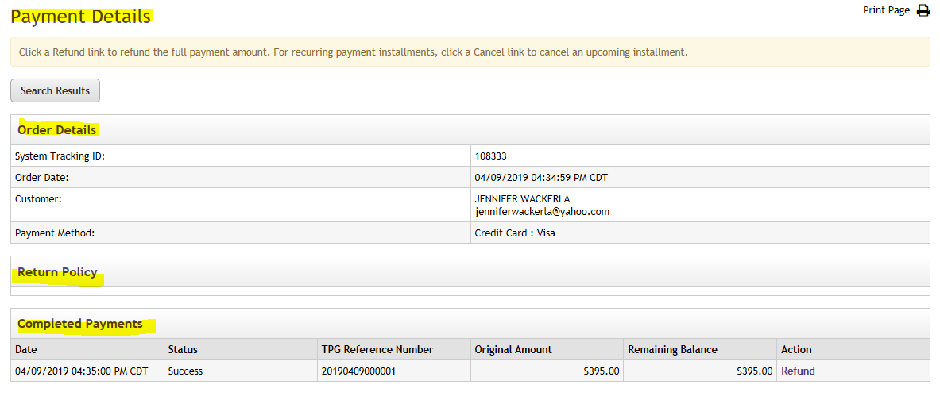

1. In the Completed Payments box click on “Refund”.

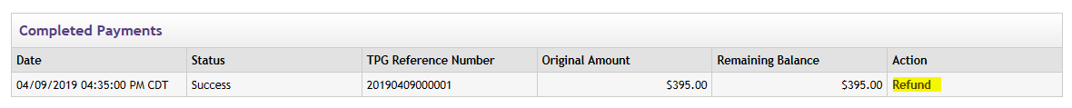

1. From the Refund Options Page, enter the amount to be refunded.

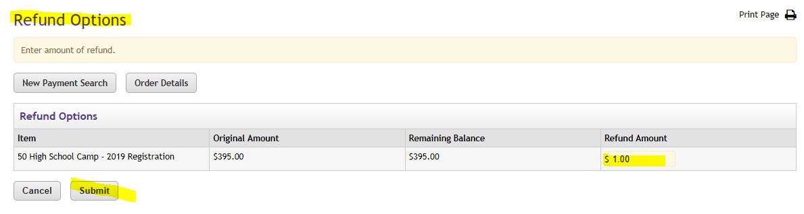

1. You do not need to complete a Miscellaneous Deposit Form (MDF) for the refunds. All activity will be recorded to department’s default funding.
2. Additional questions can be sent to [ecommerce_dl@ku.edu](mailto:ecommerce_dl@ku.edu).